MESA Activities
Mechanical Engineering Students Association
Following are the students of Mechanical Engineering Department selected for Mechanical Engineering Students Association (MESA) for academic year 2021-2022.
DESIGNATION | NAME OF THE STUDENT
PRESIDENT | Ms. SAKSHI ARALI
VICE PRESIDENT | Mr. SIDDHANT YADAV
TREASURER | Ms. ADITI INGLE
VICE TREASURER | Ms. SAKSHI HAWALDAR
SECRETARY | Ms. SIDDHI MAHAJAN
JOINT SECRETARY | Mr. AMRUT PANDE
LADIES REPRESENTATIVE | Ms. KISHORI PAWAR
CULTURAL COORDINATOR | Ms. RUTUJA SURYAWANSHI
SPORTS COORDINATOR | Mr. TEJAS NANAWARE
TECHNICAL COORDINATOR | Mr. DEVANG DHEKANE  Mr. SARAS WATEKAR
DESIGNER | Ms. CHINMAYA DHAKE  Ms. ANUSHKA DUSANE
SOCIAL COORDINATOR | MR. AMEYA MAHAMUNI
COMMITTEE MEMBERS | Mr. CHAITANYA ANDURE  Mr. PRATIK JOSHI  Ms. MANSI PATIL  Mr. AJINKYA KAMBLE  Ms. MRUNAL KHARE  Mr. PRATHAMESH ZODAGE  Mr. SHRINIWAS TONAPE  Ms. ESHA LAUTE  Ms. MRUDULA DHAMANE  Ms. AKANSHA SHETE  Mr. SANKET DESHMUKH
Following are the students of Mechanical Engineering Department selected for Mechanical Engineering Student Association (MESA) for academic year 2020-2021.

DESIGNATION | NAME OF THE STUDENT
PRESIDENT | Mr. CHAITANYA ANDHURE
VICE PRESIDENT | Ms. SAKSHI ARALI
TREASURER | Ms. ADITI INGALE
VICE TREASURER | Mr. VEDANT PAGAR
SECRETARY | Mr. PRATIK JOSHI
JOINT SECRETARY | Mr. MUSKAN TAMBOLI
LADIES REPRESENTATIVE | Ms. MRUNAL KHARE
CULTURAL COORDINATOR | Ms. SIDHI MAHAJAN
SPORTS COORDINATOR | Mr. JAYAKRISHANA SAI KADALI  Mr. CHAITANNYA ANDURE
TECHNICAL COORDINATOR | Mr. DEVANG DHEKANE
DESIGNER | Ms. NEHA INGALE  Ms. CHINMAYA DHAKE
SOCIAL COORDINATOR | Mr. SAURABH MOUNDEKAR  Ms. MANSI PATIL
COMMITTEE MEMBERS | Mr. PRATHAMESH SINGHAN  Ms. RAJASHRI CHAUDHARY  Mr. TEJAS KOLHE  Mr. ROSHAN WGHCHAURE  Mr. RUPESH JADHAV  Ms. ANUSHAKA DUSANE  Mr. SHREYAS WAGHULE  Mr. SUSHIL YESANE  Mr. DHEERAJ SOUNDAKAR  Mr. PRATIK ZENDE  MrPRATHAMESH SINGHAN  Mr.UDDESH RAJ
Activity of MESA for 2020-21
Name of Event- Online Quiz Aptitude And GK-(An intercollegiate Event)
Date of Event- 10-15 June-2020
Participant- 300
Description-
Online Event on Quizzes were taken at intercollegiate level and E certificate were given to paticipants who scored more than 40% marks
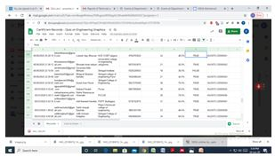 | 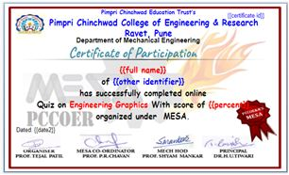

Event Name- Webinar on “Opportunities and Challenges for Engineers in EV sector.”
Date of Event- March 11, 2021.
Participant- 60
Faculty Coordinator- Prof. Priyanka Chavan
Description-
A webinar on Opportunities and Challenges for Engineers in EV sector is conducted by Suraj S. D Founder and CEO of Decibels Lab Pvt Ltd.
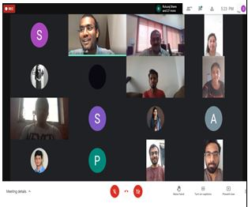 | 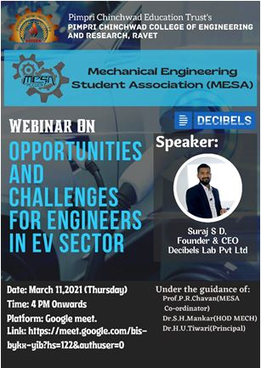
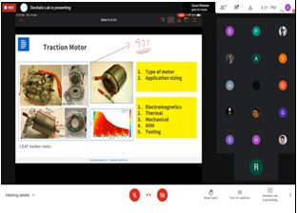 | 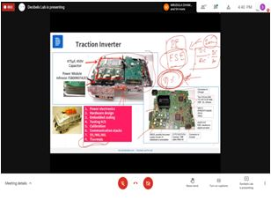

Event Name- Talk on “Introduction to ASHRAE”
Date of Event- 8/03/2021
Faculty Coordinator- Prof. Priyanka Chavan, Prof. Rupali Patil
Participant- 77
Description-
Introduction lecture on ASHRAE is conducted to give students information of different about ASHRAE membership and its benefits for student chapter formation. It was conducted by Prof. K. K. Ghosh from CME, college Khadki.
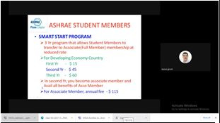 | 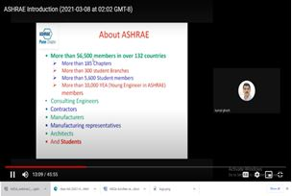

Event- Post and Prior things required for MS studies
Date of Event- 27/2/2021
Faculty Coordinator- Prof. Priyanka Chavan
Participant- 111
Description-
MESA has organized the event Post and Prior things required for MS studies, as many students of college are interested to pursue their higher education in foreign countries. So this event helped students for preparing for MS examination, applications writing, selecting the University etc. In this event PCCOER college Alumni who are already pursuing education in foreign countries were involved.
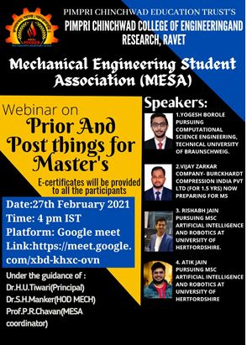 | 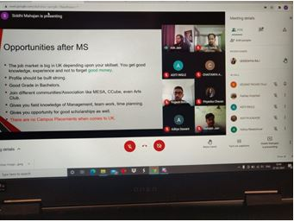
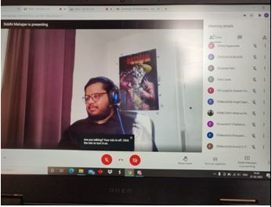

Mechanical Student Association
MESA is Mechanical Student Association. The MESA was formed in 2015 to bring about the technical development of students by organizing different technical and non-technical activities and also to improve organizing abilities of students by engendering good communication skills, managerial abilities, presentation skills and team work
Objectives:
- 1. Promoting the interests of students in various technical areas pertaining to mechanical engineering
- 2. To encourage students of the mechanical Engineering department to develop their personal skills, like event management & time management by organizing inter & inter Collegiate Events.
- 3. To bring about the technical and overall development of students by organizing seminars, workshops and other non technical activities.

MESA Logo
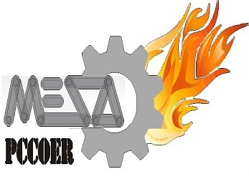

MESA Team 2019-20
Sr. No. | DESIGNATION | NAME OF THE STUDENT
1. | PRESIDENT | Mr. SAURABH MOUNDEKAR
2. | VICE PRESIDENT | Mr. RONIT PAWAR
3. | TREASURER | Mr. PRATIK MORE
4. | VICE TREASURER | Miss. RAJASHRI CHAUDHARI
5. | SECRETARY | Mr. TEJAS KOLHE
6. | JOINT SECRETARY | Mr. PRATIK JOSHI
7. | LADIES REPRESENTATIVE | Miss. SAMIKSHA UNHALE
8. | CULTURAL CO-ORDINATOR | Miss. PRANALI WAMAN
9. | SPORTS CO-ORDINATOR | Mr.CHRISTY SELVAM  Mr. CHAITANNYA ANDURE
10. | TECHNICAL CO-ORDINATOR | Mr. SHIVAM BHAVSAR
11. | DESIGNER | Mr. SAMAY MESHRAM
12. | SOCIAL COORDINATOR | Mr. RAJAS PATIL
13. | COMMITTEE MEMBERS | Mr. YOGESH BOROLE  Mr. VEDANT CHAUDHARY  Mr. ROHIT CHOTHE  Mr. SUSHIL YESANE  Mr. DHEERAJ SOUNDAKAR  Miss.MAYURI DASPUTE  Mr. ABHIJIT WAYAL  Mr. PRATIK ZENDE  Mr. ADITYA SLATHIYA  Mr.MADHUSUDAN KHEDKAR  Mr.PRATHAMESH SINGHAN  Mr.UDDESH RAJ

MESA Activities
Event name: Engineer's Day Celebration  Date: 15/09/2017  Description:  On the occasion of "ENGINEER'S DAY" the Mechanical Departmental students teams from different work areas like Baha, Go-Kart, MESA were felicitated and appreciated. | 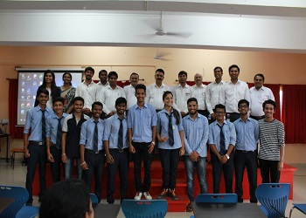
Event name: CONTRAPTION  Date: 15/09/2017  No of Participants: 12 Groups(48 students)  Description:  A contraption is energy conversion event in which student have prepared different models by using there innovate ideas to complete a given task. | 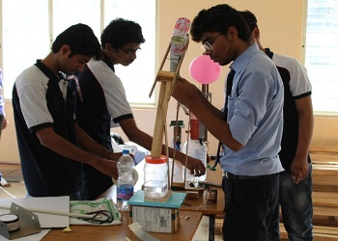
Event name: Teacher’s day  Date: 04/09/2017  Description:  On the occasion of Teacher’s Day a programme was organized by the students to show their love, affection and gratitude towards their beloved teachers on 4th September 2017. | 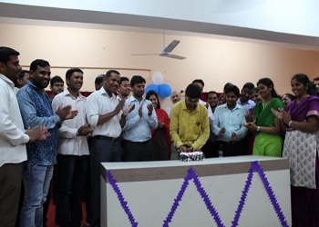
Event name: Two Day Soft Skills Workshop by K. Shridhar Rao  Date: 07/09/17 and 08/09/17  No. of Participants: 300  Description:  A two day Soft Skill workshop was arranged by the MECHANICAL Department for the Third Year and Fourth Year students to promote and prepare students towards placement. | 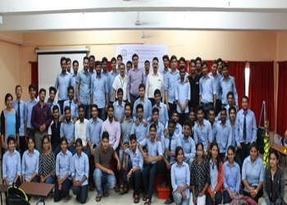
Event name: Fresher’s Party  Date: 17/07/17  Description:  Fresher’s party for Second Year students of 2017-2018 was organized and celebrated on 17th July 2017. | 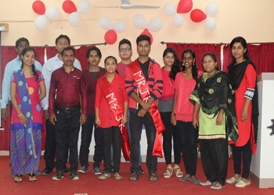
Event name: Intercollegiate Event Yantraholic-2K18  Date: 11&12/01/2018  No.of Participants: 400  Description:  A technical event organized under MESA ant Intercollegiate Level to Improve technical skill set and organizing skills of students | 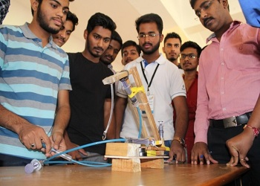
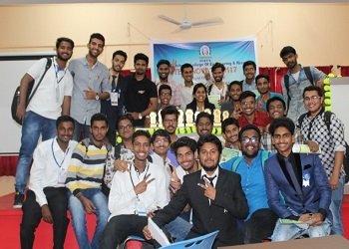 | 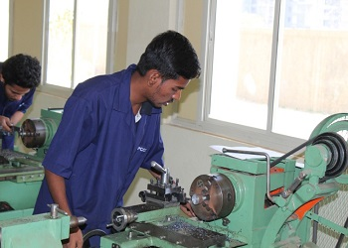
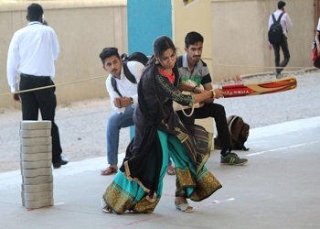 | 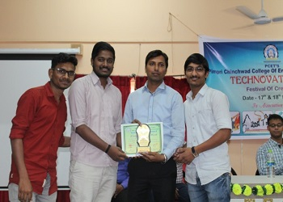
Event name: Cloth Donation Camp  Date: 14 & 16/08/2018 | 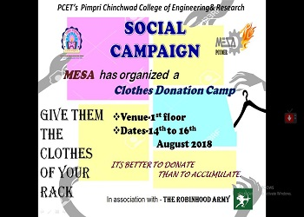
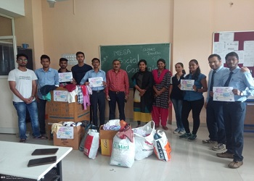 | 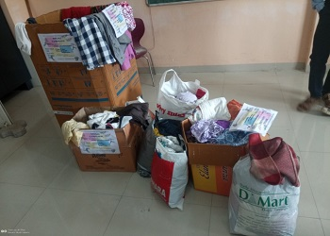
Event name: Yantraholic-2K19  Date: 08 & 09/02/2019  No.of Participants: 220  Technical Events: 06  Description:  An intercollegiate event "Yantraholic 2k19" was organised by "MESA" at "PCCOE&R" on 8th & 9th February 2019 .Many students from PCCOE, PCCOER, DYPCOE, RSCOE had participated in the event.There were 100 groups & 250 no. of students were participated in different events | 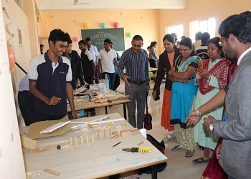
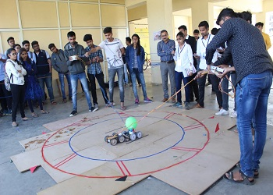 | 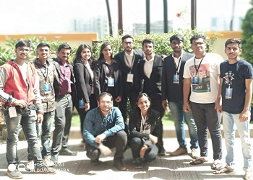
Event name: RAC Workshop  Date: 01/10/2019  No.of Participants: 35  Description:  This workshop was organized to enhance technical skills of students in field of R&AC and to improve practical knowledge by giving hands on exposure of refrigeration and Air-conditioning equipment’s. | 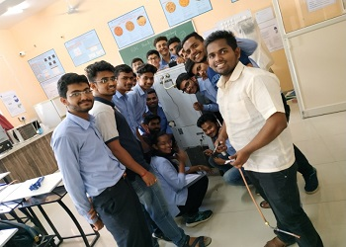
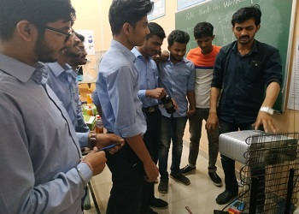 | 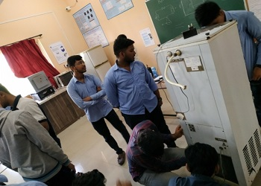
Event Name: Design of Electric Vehicle. Jointly Organized by Department of Mechanical Engineering and E&TC Engineering
Date: 15/07/2019 to 22/07/2019
Venue:Class Room No. 304, Seminar hall & Mechanical workshop
Organizing Team: Ms. Priyanka Chavan, Mr. Rahul Parbat, Ms.Deepshikha Shrivatsava

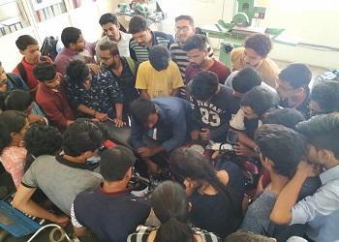 | 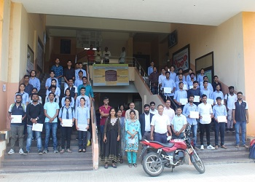

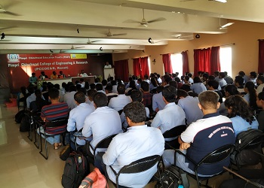

Events during Lockdown
Event Name: Online quiz on Engineering Graphics (An intercollegiate Event)
Date: 26/05/2020 to 30/05/2020
Participants: 600

*E-Certificate was awarded to the candidates who scored above 40% marks.*

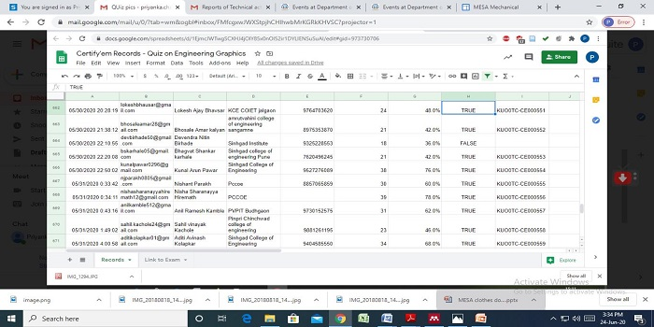

Event Name: Online Quiz Aptitude And GK-(An intercollegiate Event)
Date: 10/06/2020 to 15/06/2020
Participants: 300
*E-Certificate was awarded to the candidates who scored above 60% marks.*
